Lithuania Travel Tech Forum &
UN Tourism Pitch Challenge “Discover Lithuania”

Speakers
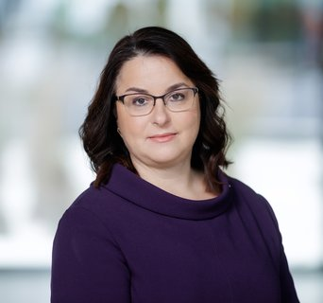 | Guoda Burokienė  Vice-Minister of the Economy and Innovation of the Republic of Lithuania  Guoda Burokienė has served as Vice-Minister of the Economy and Innovation of the Republic of Lithuania since October 2025. Her areas of responsibility include EU economic policy and the EU internal market, tourism and resort development, domestic trade and talent attraction and development. She also plays a key role in coordinating matters related to Lithuania’s Presidency of the Council of the European Union within the Ministry’s areas of competence.  Guoda has extensive experience in public policy, parliamentary affairs, rural development and international cooperation. From 2016 to 2024, she served a Member of the Seimas of the Republic of Lithuania. Earlier in her career, she worked as a geography expert at the European Network for Rural Development in Brussels and chaired the Lithuanian Rural Communities Union. She also held senior positions at the Lithuanian Chamber of Agriculture and the Lithuanian Farmers’ Union.  Guoda Burokienė holds a degree in Energy Studies from Kaunas University of Technology. She speaks English, Russian and Polish.  🔗 LinkedIn: Guoda Burokiene | LinkedIn
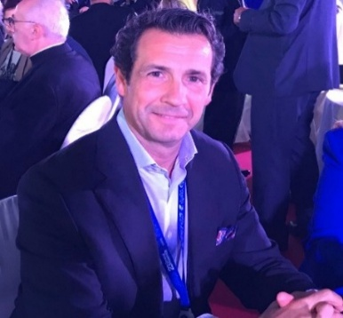 | Antonio López de Ávila  Director of Innovation, Education and Investments, UN Tourism  With over 20 years of experience in innovation strategy, smart tourism, and smart destinations, Antonio leads the Innovation, Education and Investment Department at UN Tourism.  He has a strong background in entrepreneurship, education, and public sector leadership, co-founded five companies, taught innovation management at IE Business School, one of the top business schools worldwide, and researched various topics related to tourism innovation. Furthermore, Antonio served as the President-CEO of SEGITTUR, the Spanish public company for tourism innovation and technology, where he launched the Smart Destination Initiative, a pioneering and influential global project that changed the way tourism strategy is planned in the 21st century.  🔗 LinkedIn: Antonio López de Ávila Muñoz | LinkedIn
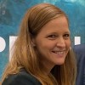 | Nina Kušar  Programme Officer, Regional Department for Europe, UN Tourism  As a Programme Officer in the UN Tourism Regional Department for Europe, Nina focuses on programme development, stakeholder coordination, monitoring tourism policy developments and the implementation of international cooperation projects.  Prior to joining UN Tourism, Nina worked at the Embassy of Slovenia in Madrid and with UNICEF Slovenia, gaining experience in international relations, project management, communications, fundraising and campaign management.  She holds a Bachelor's Degree in Law from the University of Ljubljana and a Master's Degree in International Development Cooperation and Humanitarian Aid from the Open University of Catalonia.  Alongside her professional career, she has been extensively involved in volunteer work, particularly through the Scout movement, where she has held a range of leadership positions.  🔗 LinkedIn: Nina Kušar | LinkedIn
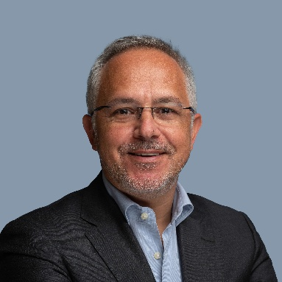 | Sérgio Guerreiro  Senior Director, Strategy & Knowledge Management, Turismo de Portugal  PhD in Tourism. Almost 25 years of experience in the tourism sector in the areas of strategy, market intelligence, tourism policy and innovation. Senior Director for Strategy & Knowledge Management at Turismo de Portugal and Chairman of OECD Tourism Committee; Vice Chair of UN Tourism Committee on Statistics and previously Chair of the European Travel Commission’s Market Intelligence Group. Tourism Expert in several workgroups from international organizations such as EU, UN Tourism, OECD, ETC and WEF.  Invited Professor at Nova School of Business and Economics, Nova Information Management School and Universidad Europea das Canarias  🔗 LinkedIn: Sérgio Guerreiro Linkedin
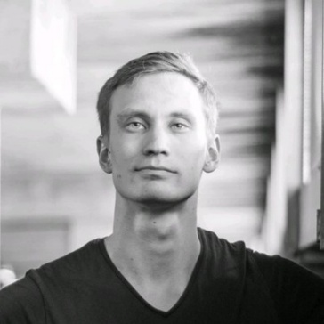 | Vesa-Matti Ruottinen  Development Manager, City of Tampere  Vesa-Matti Ruottinen, M.Sc., is a creative and ambitious innovator dedicated to integrating technology with human-centered development. As a Development Manager at the City of Tampere, he drives forward-thinking solutions that support the growth of the city. With a strong background in startups and the startup ecosystem, he believes the best results come from teamwork, where people thrive together.  Linkedin: Vesa-Matti Ruottinen - Tampereen kaupunki - City of Tampere | LinkedIn
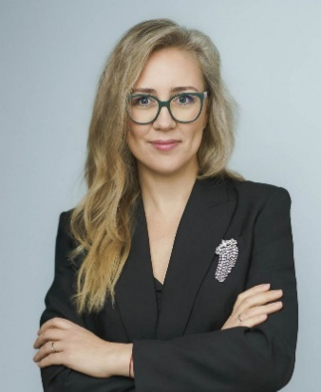 | Olga Gončarova  General Manager of the National Tourism Promotional Agency Lithuania Travel  Olga Gončarova is a tourism professional with over 15 years of experience in B2B marketing, communications, and strategic planning. She currently leads Lithuania Travel, the national tourism development agency. Olga is responsible for shaping Lithuania’s tourism image and bringing tourism ecosystem together. She specializes in working with priority target markets and maintains close collaboration with foreign tour operators, media representatives, and other tourism stakeholders to promote inbound travel to Lithuania and domestic tourism as well. Her strategic mindset and international expertise contribute to positioning Lithuania as an attractive, authentic, and sustainable travel destination.  🔗 LinkedIn: Olga Goncarova | LinkedIn
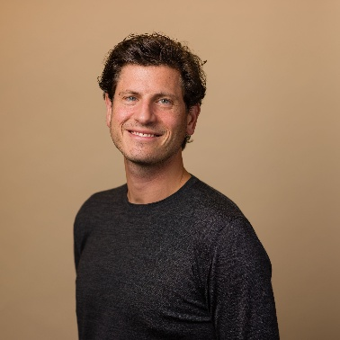 | Thijs Koster  Policy Advisor, Visitor Economy, City of Amsterdam  Thijs Koster works at the intersection of hospitality, sustainability and tourism policy. He began his career building and running hospitality businesses under full commercial responsibility, including a Michelin-starred restaurant, where he integrated sustainability under real operational and financial pressure rather than as a marketing layer.  He currently advises the City of Amsterdam on visitor economy policy, working on how to guide behaviour and protect public value without blocking the market dynamics that make tourism work. Alongside this, he is co-founder of My Treats, a platform connecting restaurants, consumers and sustainability data. Built from the same conviction that sustainability claims only matter if they hold up under commercial and regulatory scrutiny.  Across both roles, Thijs brings operator-level experience to questions of how destinations, businesses and public frameworks can work together without one undermining the other.  🔗 LinkedIn: Thijs Coster | LinkedIn
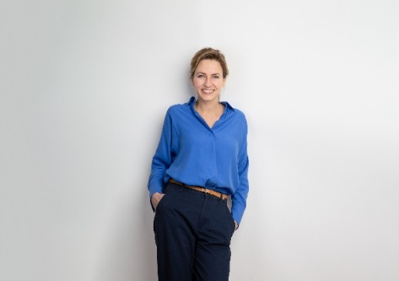 | Monika Miniotaitė  Director of the Panevėžys Development Agency  Monika’s professional experience includes economic development, innovation, investment attraction and city positioning. Since 2021, she has led a team working on initiatives ranging from Industry 4.0 and business innovation to talent attraction, tourism and city marketing. In a city where tourism has not traditionally been a priority, Monika sees it as a way to strengthen Panevėžys’ identity and visibility. This includes looking for authentic niches, such as industrial tourism, that build on the city’s strengths, while exploring how sustainability and new technologies can support this process. This approach has already gained recognition at both national and European level. Monika brings a practical perspective on how cities outside traditional tourism routes can identify what makes them distinctive and turn it into new opportunities.  🔗 LinkedIn: Monika Miniotaite | LinkedIn
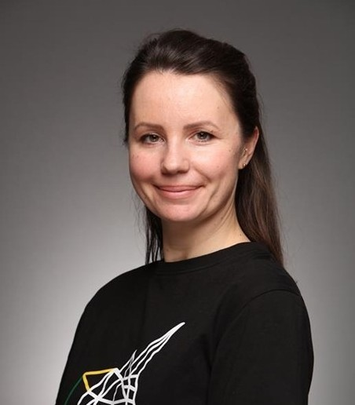 | Akvilė Dobromilskytė  Sector Development manager at Startup Lithuania / Innovation Agency Lithuania  Akvile works at the intersection of startup ecosystems, international partnerships, and program development. At Startup Lithuania, part of Innovation Agency Lithuania, she connects startups, investors, institutions, and international partners through ecosystem initiatives, cross-border programs, and investor matchmaking.  With a background in european and international business law, she combines strategic thinking with hands-on experience in turning ideas and policies into practical initiatives that support startup growth and international collaboration.  Linkedin: https://www.linkedin.com/in/akviledo/
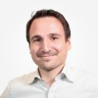 | Guillaume FIRMIN  Senior Manager, Amadeus Innovation Office, Foresight & Co-Innovation  Guillaume FIRMIN is passionate about innovation and enjoys working with teams to explore new ideas, experiment with fresh approaches, and connect foresight with real business opportunities. Over the past years at Amadeus, he has helped build a strong innovation culture by designing and facilitating nearly 50 workshops and co-creating projects with colleagues, customers, and partners.  One of the initiatives he is most proud of is the Amadeus Innovation Academy, a hands-on program that has trained more than 1,500 employees in Design Thinking and Lean Startup methodologies.  Guillaume leads the Foresight & Co-Innovation Department at Amadeus, with a mission to strengthen foresight capabilities and foster co-innovation with customers and partners. His work focuses on engaging stakeholders through collaborative innovation, enhancing foresight in close cooperation with Research, Tech Watch, and Strategy teams, and supporting technology exploration, including initiatives within the AI Office. He is particularly passionate about bridging foresight and execution, transforming bold ideas into actionable opportunities that shape the future of the travel industry.  🔗 LinkedIn: Guillaume Firmin | LinkedIn
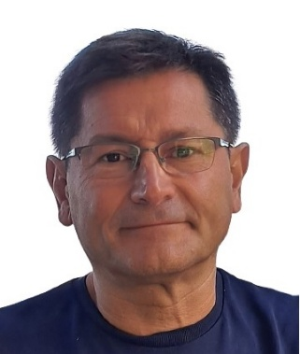 | Faustino Cuadrado  Technology Entrepreneur | Strategy, Growth & Operations Executive  Faustino Cuadrado Capitán is a technology entrepreneur and senior strategy and operating executive with more than three decades of experience across telecommunications, e-commerce, mobility SaaS and AI-enabled travel technology. He currently serves as Chief Growth Officer at iUrban Digital Tourism, where he leads fundraising and expansion strategy.  His career spans founder, CEO, COO, CTO and general management roles at organisations including AmazonBuyVIP, ADP ES Iberia, Jazztel, Red Eléctrica Telecomunicaciones, Nokia Networks and Albedo Telecom. At AmazonBuyVIP, he helped scale a European consumer technology business through fundraising, international execution and exit planning before its acquisition by Amazon in 2010. Across these roles, he has built businesses from the ground up, transformed operating models and led multidisciplinary, multicultural teams.  Faustino combines corporate strategy, investor relations, M&A, performance management and hands-on execution. He is at his best where strategy meets delivery, which is fortunate: the two are often introduced, but rarely seen together. He holds a degree in Computer Science Engineering from the Universitat Autònoma de Barcelona and completed the General Management Program (PDG) at IESE, alongside executive development. Based in Barcelona, he works comfortably across international and multicultural environments.  🔗 LinkedIn: Faustino Cuadrado Capitán | LinkedIn
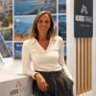 | Manuela López  Sales & Operations Manager at Nordis Travel ApS  Manuela Lopez works in a leading Scandinavian and Baltic destination management company based in Copenhagen.  She specializes in developing and delivering travel solutions for tour operators and travel agencies, with particular expertise in Nordic and Baltic destinations. Her work focuses on travel operations, product development, and building partnerships across international tourism markets. Through her extensive experience in destination management, she helps create high-quality travel experiences connecting global travelers with Northern Europe's most distinctive destinations  🔗 LinkedIn: https://www.linkedin.com/in/manuelalopezmauri/
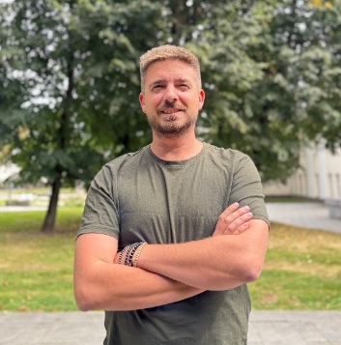 | Tadas Kertenis  CEO & Founder, Hoperfy  Tadas Kertenis is the CEO and Founder of Hoperfy, a company operating in the tourism and events industry. Hoperfy's core business focuses on providing hotel integration solutions for international conferences and events, helping organizers streamline accommodation management while creating additional revenue opportunities for their events.  In parallel, Hoperfy is developing an innovative business travel platform designed for corporate clients. The platform enables companies to access flights, hotels, and professional travel planning tools through a single, user-friendly environment, simplifying the management of business travel and enhancing efficiency.  With a strong focus on technology, innovation, and value creation for event organizers and business travelers, Tadas is committed to building solutions that make travel and event management smarter, more seamless, and more profitable.  🔗 LinkedIn: Tadas Kertenis 🏨 | LinkedIn
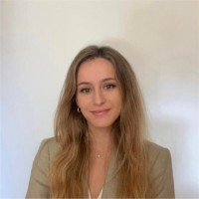 | Paula de Blas  Senior Project Specialist, Innovation, Education and Investments, UN Tourism  Paula de Blas González is an international development professional with expertise in education, innovation and project management. Having lived in seven countries, she brings a strong multicultural perspective to her work.  With more than seven years of experience within the United Nations system, Paula has worked across several UN entities, including UNITAR, the UNSSC, and, currently, UN Tourism as Senior Specialist in Innovation, Education and Investments.  Prior to joining the UN system, she gained experience in several Spanish public institutions, including the Spanish Embassy and offices focused on trade and investment, and education.  Paula holds two master’s degrees, in International Development, and in Innovation, as well as two undergraduate degrees in International Relations, and in Translation and Interpreting.  🔗 LinkedIn: Paula de Blas González | LinkedIn
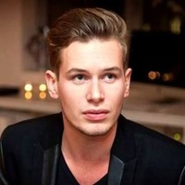 | Glenn Cauwenberghs  Senior Project Specialist, Innovation, Education and Investments, UN Tourism  Glenn Cauwenberghs 10 years of professional experience working as a coordinator and project manager in a multicultural environment, both in the private and public sector. As an employee he is a team player who always starts new projects with a critical mindset and a new vision. Communication and languages are two important aspects of his professional and personal life. He is a very social and dynamic person with a constant drive to learn and shows great interest in new cultures and people.  Over the past years he has developed a strong interest for international relations and event management, in addition to his strong affiliation with architecture, literature, history and music.  He speaks and writes professionally in Dutch, French, English and Spanish.  🔗 LinkedIn: Glenn Cauwenberghs | LinkedIn
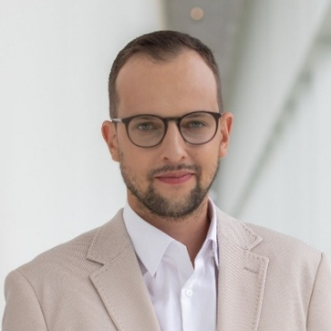 | Tadas Stankevičius  Master of Ceremonies, CEO of “Kaunas Inn”  Tadas Stankevičius is the Director of Kaunas IN, the municipal agency driving economic development, foreign investment, and tourism marketing for the city of Kaunas. With nearly a decade of leadership across destination management, startup ecosystem development, and regional investment promotion, Tadas works at the intersection of public innovation, tourism, and business growth. Known for fostering scalable tech initiatives and international partnerships, he brings a practical perspective on how technology and innovative business models are reshaping modern travel and destination competitiveness.  🔗 LinkedIn: Tadas Stankevičius | LinkedIn

